Table of Contents

1 Topology 2

2 Floor Planning and Justification (NP069476): 3

2.1 Justification: 5

3 Floor Planning and Justification (NP069483): 7

3.1 Justification: 9

4 Floor Planning and Justification (NP069464): 12

4.1 Justification: 13

5 Floor Planning and Justification (NP069472): 16

5.1 Justification: 16

6 Configuration and Demonstration 20

7 PEER EVALUATION FORM 22

7.1 Student Name/ TP Number: Pramod-Adhikari/ NP069472 22

7.2 Student Name/ TP Number: Maulik Shahi Thakuri/ NP069464 23

7.3 Student Name/ TP Number: Sampanna Adhikari/ NP069483 24

7.4 Student Name/ TP Number: Rigzeen Sherpa/ NP069476 25

# Topology

In the project we have used star Topology. In star topology devices are connected to a central switch. The man reason why we are using this network are:

Scalability:

As in star topology all other end devices are connected to single topology so it becomes easier for the building to add new End device with the increase in the worker.

Easy to troubleshoot:

All the devices are connected to the switch so it becomes easier to troubleshoot when needed and we can simply use the command to find which computer is having a problem.

High performance:

All the devices are connected to a single switch so there is no sharing of bandwidth which is why the performance of each computer is fast.

Security:

Even if one device is compromised it will not affect the rest of the computer connected to any device which is why there is high security.

Therefore star topology is a reliable and efficient network topology which is widely used in computer networks.

# Floor Planning and Justification (NP069476):

(Rigzeen Sherpa)

First floor of Harper

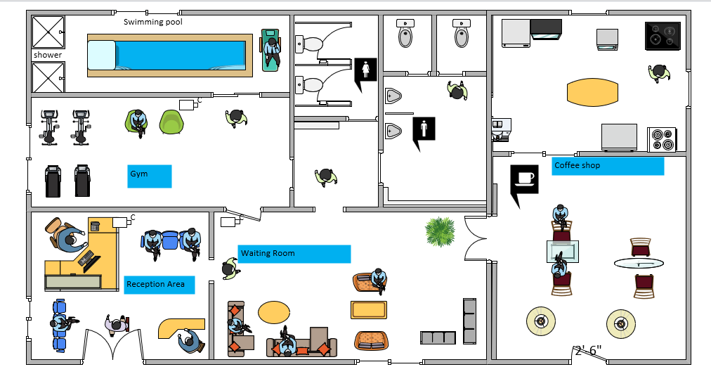

The 1st floor of the Harper building consists of five chambers (rooms), and each room is separated for a different purpose. 1st room is for the entrance where the reception area is located to receive visitors. The reception area is provided with a computer, scanner, printer, CCTV, telephone, and other electronic devices. Counseling is done in this room and information is delivered to the visitors. 2nd room is provided with a TV and sofa where visitors can wait there. 3rd room is designed for the gym where a swimming pool is facilitated for athletes. There is a coffee shop in the 4th room for refreshments and drinks. A small room is built for restrooms. All rooms are provided with basic requirements such as computer, CCTV, TV, printer, scanner, telephone and Wi-Fi for the respective use.

IP and Subnet: Floor 1(Rigzeen Sherpa)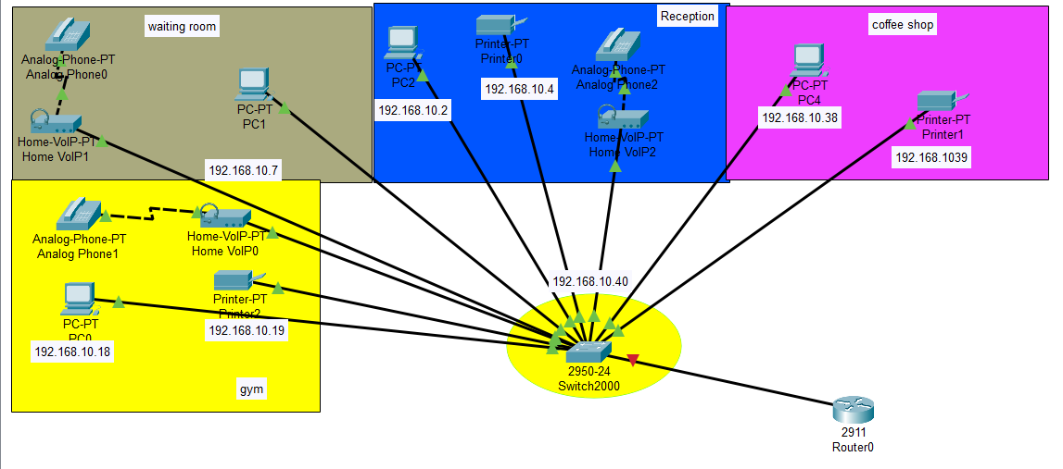

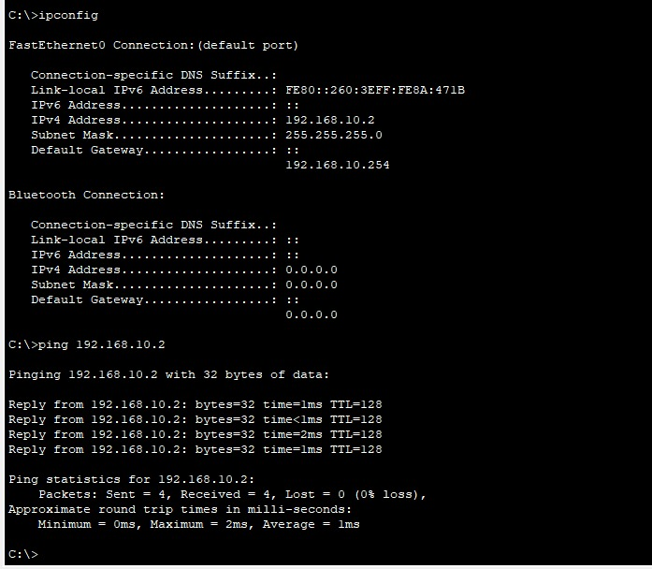

## Justification:

The whole floor of the Harper block is provided with four computers and they are assigned with IP address 192.168.10.2-192.168.10.40 of subnet mask 255.255.255.0 and their Broadcast IP is 192.168.10.255 as shown.

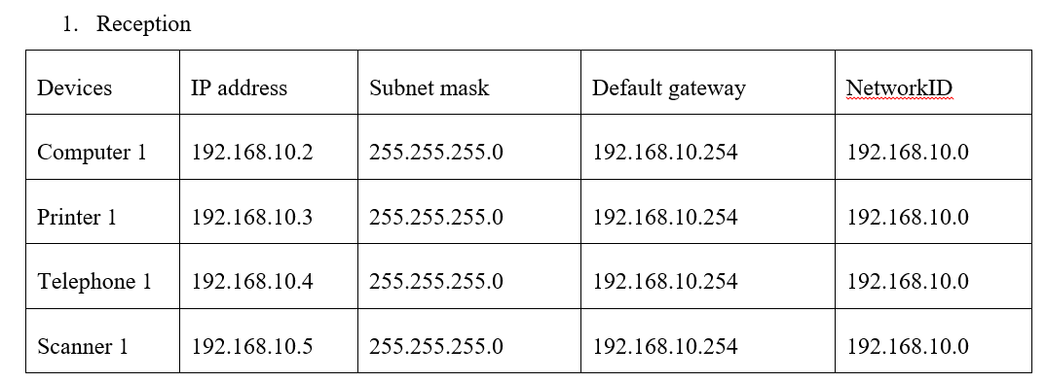

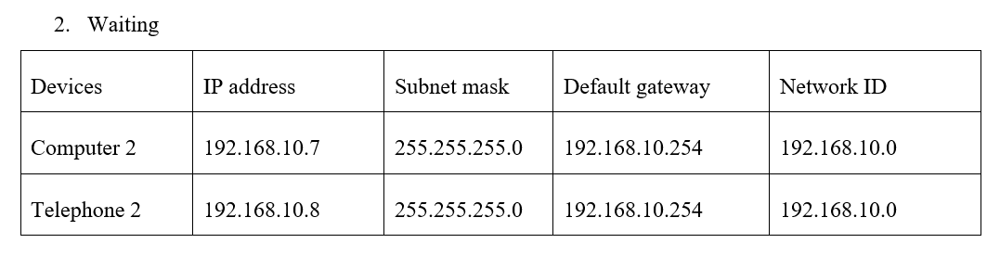

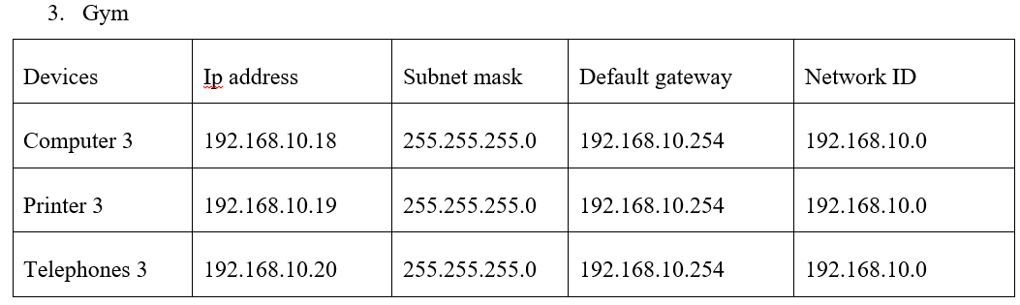

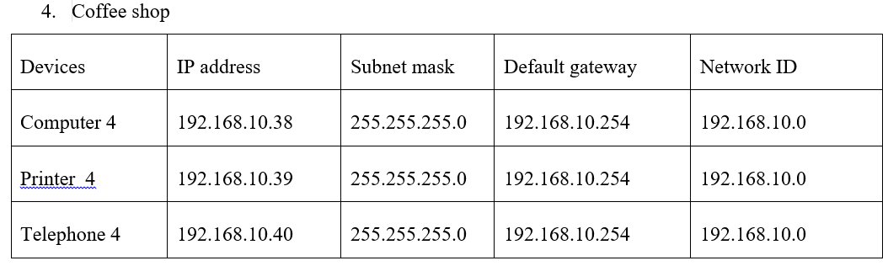

# Floor Planning and Justification (NP069483):

Name: Sampanna Adhikari

Second floor of Harper

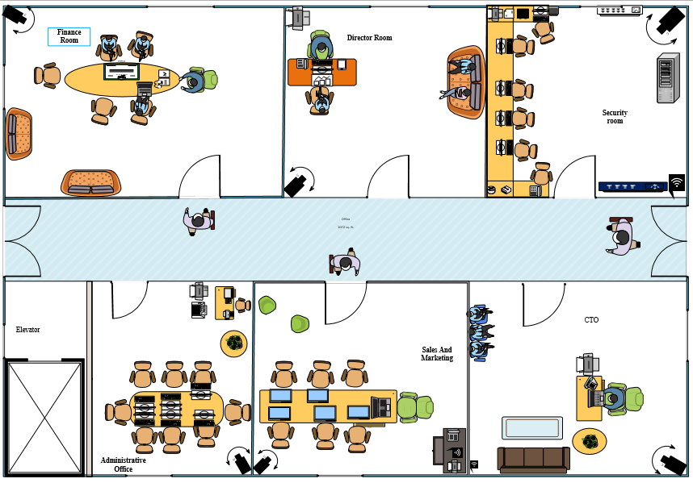

This is the second floor of the building named Harper which consists of a total of seven rooms which consists a total of six rooms each of which has a different purpose. At first, the room right beside the elevator is the Administrative Office whose work is to control the official work and provide the required information to the employee. That contains 8 chairs and a long working desk, 6 PCs and a separate desk containing a fax machine, a printer, a desktop copier and also a shredding machine. There's the Sales and Marketing room beside that room, which has 7 chairs and 6 PCs in a long office desk. In the corner is a desk with a printer, a telephone, and Wi-Fi. All right, the room besides that one is the CTO which have a set of guest seat and people are seating there and a sofa and a glass table for guest. And on the right side, there’s a desk and an executive chair. The desk has different office materials like a printer, a PC, a telephone and at last a Wi-Fi. Above the CTO room, there’s a Security room with 3 to 5 PCs and a long U-shaped desk with each required chair as the PCs. It also has Wi-Fi, a server, a printer, a router, and a switch. Altogether all of the room consists of CCTV cameras which help keep the data of every person who came to the second floor.

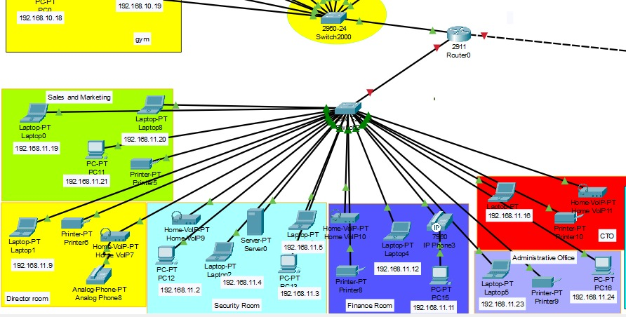

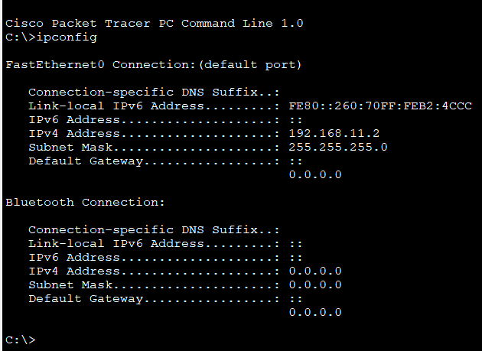

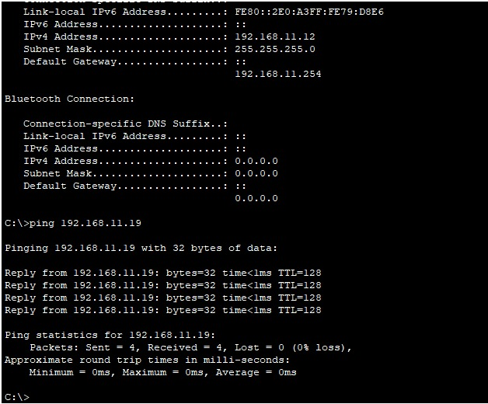

## Justification:

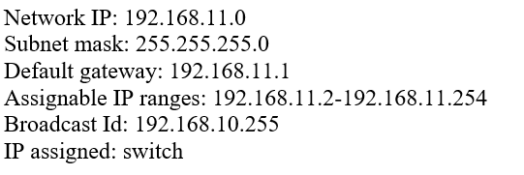

The second floor Harper has a unique organization IP address of 192.168.11.0.The subnet mask for all the rooms in second floor is 255.255.255.0. There are various devices in each of the room are connected such as PC, Laptop, VOIP, Printer, etc. The network in this floor ranges from 192.168.11.2-192.168.11.254. This floor have CCTV cameras and Wi-Fi in all rooms. These rooms have both wired and wireless connection. The IP assigned for this floor is Switch and it have a default gateway which helps in the passage of the network in various rooms. It has a Broadcast Id of 192.168.10.255 which helps in the transfer of the IP address.

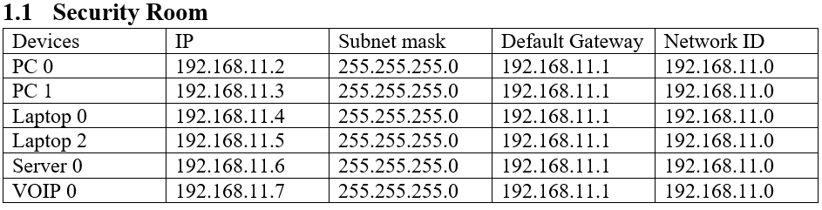

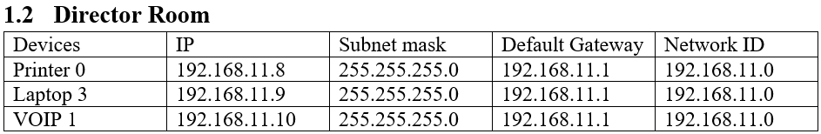

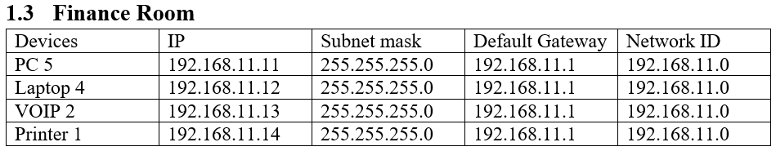

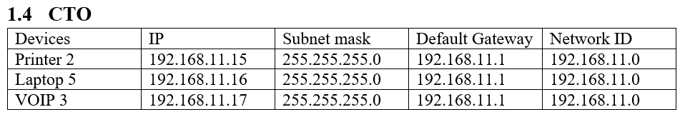

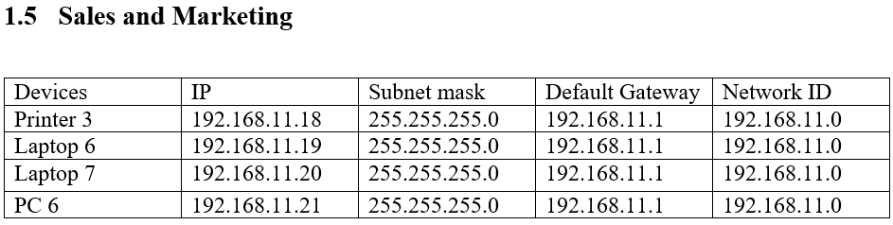

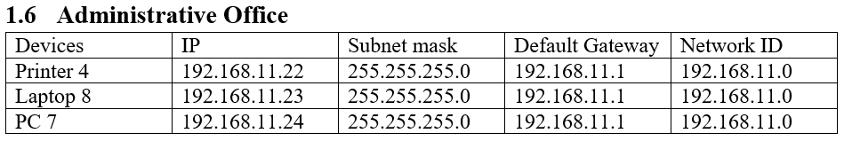

# Floor Planning and Justification (NP069464):

Name: Maulik Shahi Thakuri

First floor of Cacis

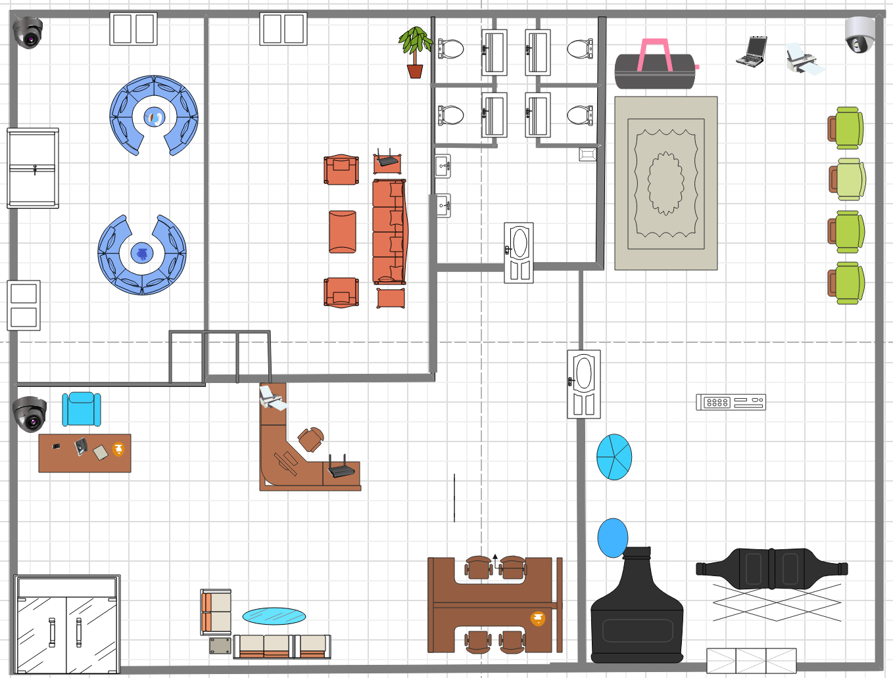

So, this is the whole diagram of the CACIS first floor where we can see there are three entrances on this whole floor. So, you can enter from the reception, café, and gym. So, there is 5 Room on this floor (Reception, Café, Waiting room, Restroom, Gym). So, starting from the main door there is a Reception room where there are two computers for the employees, one printer for printing, one wireless adapter and a CCTV. There is a waiting area with a computer after the reception where you can relax on the sofa. There is a café on the left where you can take a little rest in the interim. A PC and a CCTV are present. There is rest room where you can rest in your darkest hours and on the right side of rest room and reception there is the gym where you can exercise as there is one printer and a computer.

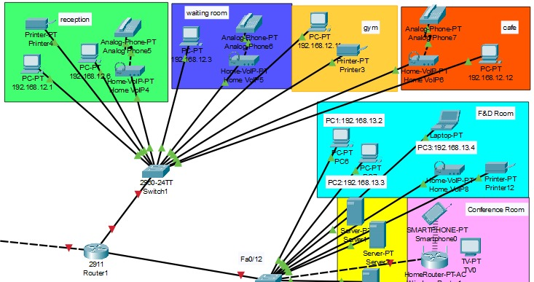

## Justification:

Network IP: 192.168.12.0/24

Subnet Mask: 255.255.255.0

Default Gateway: 192.168.12.1

Assignable IP addresses: 192.168.12.2 – 192.168.12.253

Broadcast ID: 192.168.12.255

So, this is the total number of devices used in the whole floor planning. As there is a total of 5 floors on the first floor of CACIS, where there are 4 floors with devices except rest room as there are no devices used in the restroom. In the Reception, there are two computers (Computer1 (192.168.12.1) and Computer2 (192.168.12.6)), one telephone, and a printer. In the waiting room, there is one computer (192.168.12.3) and a telephone. In the Gym room, there is one computer (192.168.12.11) and a printer. In the café, there is one computer (192.168.12.12) and a telephone.

1. WAITING ROOM

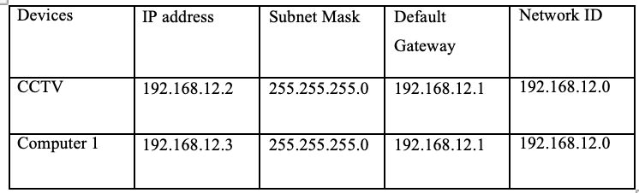

2. RECEPTION

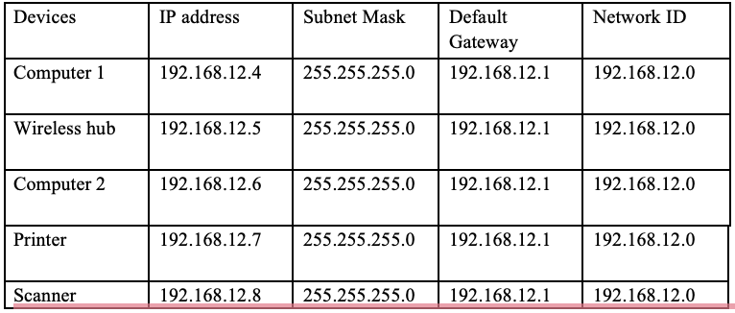

3. GYM

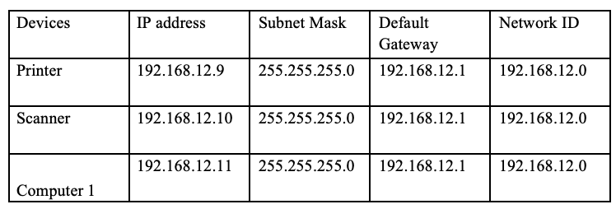

4. CAFE

# Floor Planning and Justification (NP069472):

Name: Pramod Adhikari

Second floor of Cacis

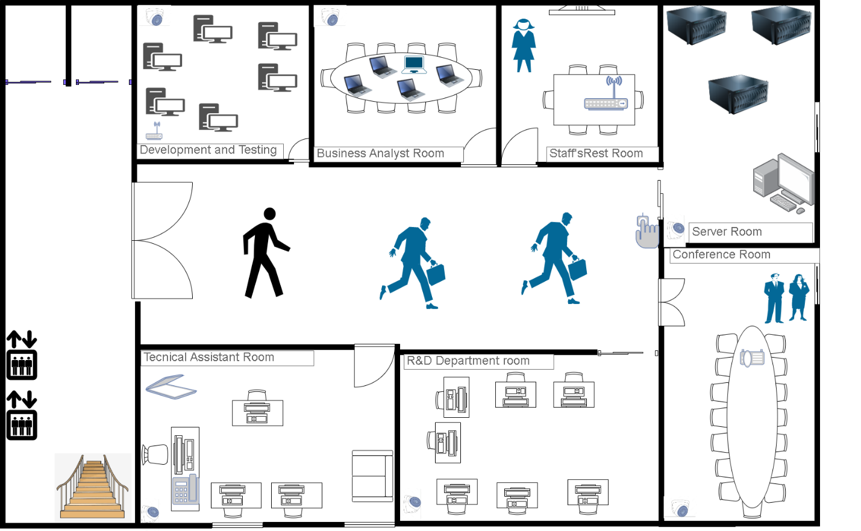

## Justification:

The above shows the design of building 2 floor 2 Cacis which is in Melbourne, Australia. This floor consists of 7 Rooms. You can go to this floor by elevator or stairs. The double-sided door can be used to enter the floor.

Each room on this floor consists of CCTV except for Staff’s restroom. The CCTV used on the floor are of VIP vision products which is a Chinese product as no security cameras are manufactured in Australia(according to GOOGLE). So VIP Visionproductt is used on this floor.

The computer used on this floor is of high speed for better performance and combability as this floor consists of important floors such as the Business analyst Room, Development and testing, technical Assistant Room, Conference, and server room.

Various electronic devices such as printers and scanners are used by a brand named Brother.

TV of LG company is used in Staff’s Rest Room are the entertainment of Staff and wifi is installed for the Satff.

Technical Assistant Room consists of a computer table, CCTV, scanner, printer, and sofa.

R&D Department consists of 7 computers For the worker.

The conference consists of a projector, a computer, and a large conference table for the presentation and discussion of work.

The server Room consists of 3 servers for the office and a server with a computer for other work.

The staff restroom consists of wifi, a TV, and a small table for the staff to rest.

The business Analyst room consists of Round Table for the discussion, CCTC, and a laptop and computer for the staff.

Development and Testing Roon consist of 6 computers and wifi modem and CCTV.

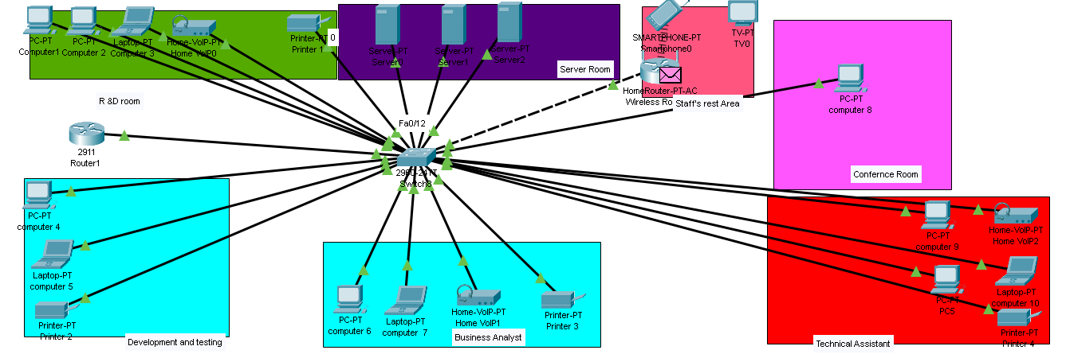

Network IP: 192.162.13.0

Subnet Mask: 255.255.255.0

Default Gateway: 192.168.13.1

Assignable IP addresses: 192.168.13.2 – 192.168.13.254

Broadcast ID: 192.168.13.255

1. R&D Department

1. Development and Testing

1. Business AnalystTable

   Description automatically generated
2. Technical AssistantTable

   Description automatically generated
3. Conference RoomTable

   Description automatically generated
4. Staff's rest Area

1. Server Room

# Configuration and Demonstration

For the data to be transfer within the all floor the building we have assemble all the floor and their computer used in one picture and used the ping command from one to another floor so that we can know the data is being transfer.

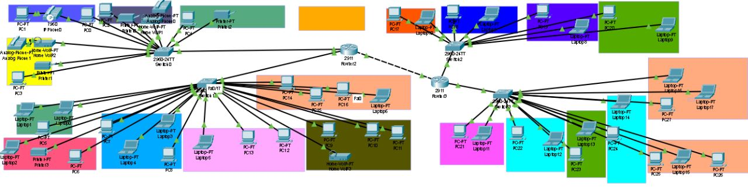

# PEER EVALUATION FORM

## Student Name/ TP Number: Pramod-Adhikari/ NP069472

**Please answer ‘Yes’ / ‘No’**

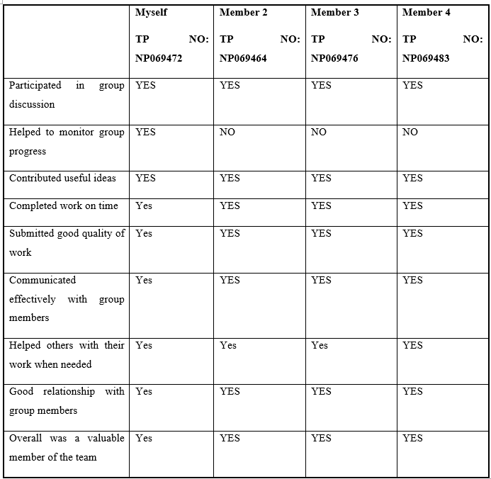

**Self-Reflection**:While doing the project I found out about various tools and equipment used in the cisco packet tracer and the difficulties when connecting two routers together and using various commands used to configure the router. Not only that, but I also learned the various commands used by the router and their function as well as uses of VOIP. In addition to learning cisco I also learned about group leadership, managing group members and coordination with them.

## Student Name/ TP Number: Maulik Shahi Thakuri/ NP069464

**Please answer ‘Yes’ / ‘No’**

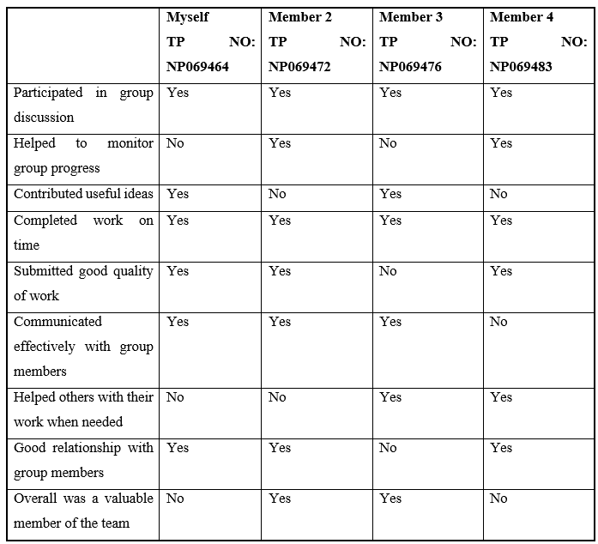

**Self-Reflection**:From this group assignment I get a chance to know that about how the IP works, how to work effectively in a group and how to make a floor planning which was helpful foe designing a networking idea and I get to know how each IP relates to each other from the IP configuration.

## Student Name/ TP Number: Sampanna Adhikari/ NP069483

**Please answer ‘Yes’ / ‘No’**

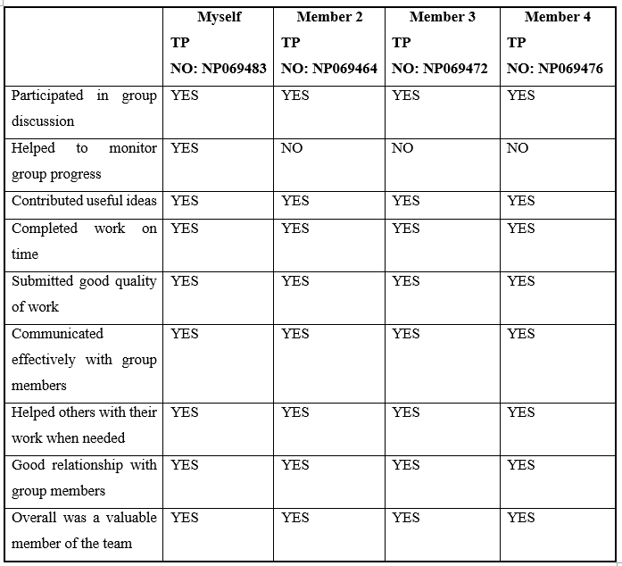

**Self-Reflection**:During this assignment I’ve got some of the ideas the IP address and its configuration. During this process I’ve gathered some of the essentials equipment and also some of the tools to make a floor diagram as well as cisco packet tracer.

## Student Name/ TP Number: Rigzeen Sherpa/ NP069476

**Please answer ‘Yes’ / ‘No’**

